Welcome to Swicegood Music and thank you for considering us as you begin 6th grade band with your student.

We offer a rental/purchase program for beginner instruments. Your down payment gets you an instrument for a trial period that ends in December. Your monthly payments would begin in January. Down payments are $75.00 for all instruments except saxophone. Down payment for the saxophone is $100.00. Monthly payments last from 27-30 months. Payment amounts vary with the different instruments.

If you choose to pay cash, we discount the instrument 30% from the list price.

At the end of the payment schedule, you will own the instrument. If at any point during the payment schedule you decide that you would like to return the instrument to Swicegood Music, the remainder of the payment schedule will be cancelled. You also have the option of paying off the instrument during the payment schedule and the unpaid balance will be discounted 20% at that time.

To begin the process, we ask that you fill out our Disclosure form located on our website. Our website is www.swicegoodmusic.com and at the top of the page click on the Disclosure link. Or you may scan the QR Code located at the bottom of this page. Please make sure the form is completely filled out.

The Disclosure form needs to be emailed to our office: sales@swicegoodmusic.com

After receiving your form, a Swicegood representative will call you to discuss the specifics of your instrument purchase. We ask that you give us some time to call you as we deal with an increased number of phone business due to the current COVID pandemic. Please make sure to include a daytime phone number on your Disclosure form. Our business hours are as follows: 8:30-5:30, Monday-Friday, and 8:30-3:00 on Saturday.

When we call, we will be happy to answer any questions you may have, accept your down payment, and take care of any supply orders you may have that your directors have requested.

We will arrange to have all instruments delivered to your school based on the directors’ timeline for their campus.

Thank you for your interest in Swicegood Music. We look forward to helping you as your student begins their band journey!
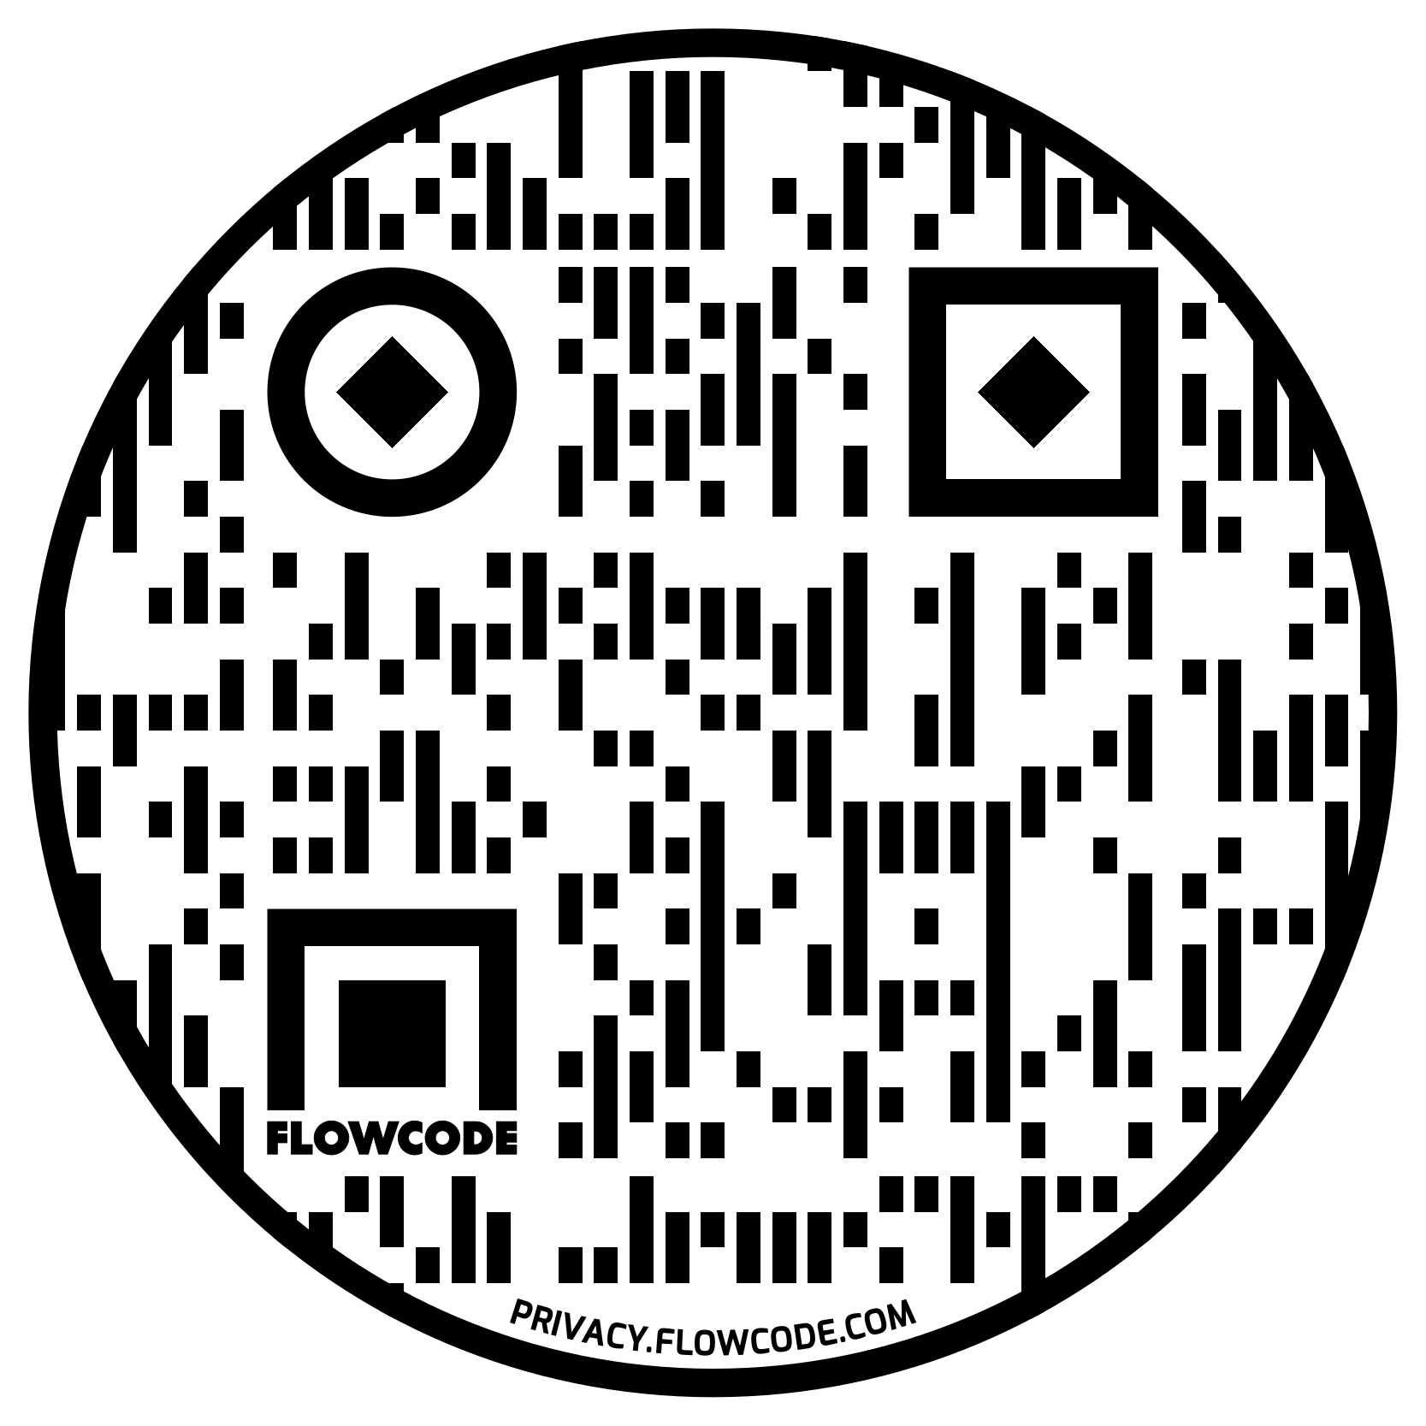

Swicegood Music
409-833-8603
800-249-3622

